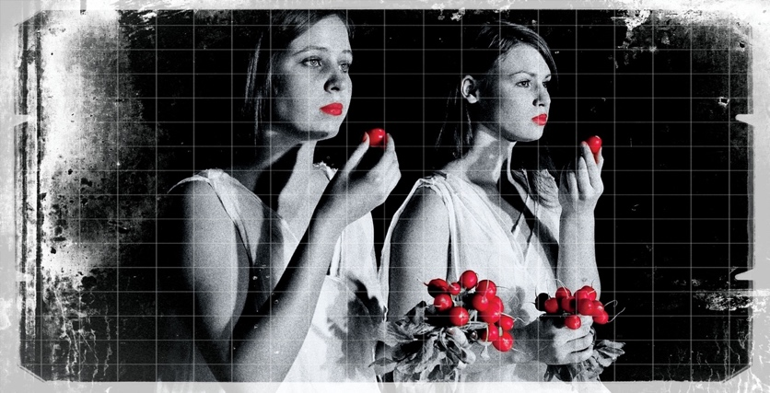
geolocated sound exibition
KARMINA ŠILEC MUSICA INAUDITA
music by female composers
performers: Carmina Slovenica conductor: Karmina Šilec
permanent exibition from 3.10.2022 at STIAS Stellenbosch, South Africa
HOW:
bring phone or tablet + earphones
download app: ECHOES interactive sound walks
get link via QR Code
stream walk

